Project of our cyber café “cyber field”.
Internet cafe business is a very interesting business. Computer technology is evolving rapidly from day to day. Suppose you opened a cyber cafe business a year ago, computers that you bought at that time could be considered outdated. At present, broadband high-speed internet access is readily available everywhere and the rates are quite cheap. You only need to bring your own laptop or netbook if you want to access the Internet.
What I see, internet cafes are no longer as they were introduced about ten years ago. However the internet cafe is still the choice for entrepreneurs as a business option. Most of them are from people interested in computer field. They get involved in internet cafes because of their interest in computers. Indeed you must have interest to last long in this business is full of many challenges in terms of competition, maintenance problems and customers variety.
We divide our project into several parts.
- Money needed.
Start-up capital of our project is about 40 000€ and we are planning to take a portion of this amount from our savings and borrow another in bank.
This is how we are planning to spent this money:
    - 30 computers for 700 € (total 21000€)
    - 4000€ for repairing the room
    - Furniture will cost about 2000€
    - 2 air-conditioner for 1200€ each (total 2400€)
    - Software for 3000€
    - 3000€ for internet equipment
We will also have costs each month:
    - About 900€ -- rent of the room
    - 400€ for the advertising
    - 150€ for the cleaner
    - 100€ for the internet
    - 100€ for other costs

- Type of customer.
Our cafe is designed for young customers because pupils and students most use the internet for studying, communication and playing games. Why are they go to the Internet café? Is it because they have no computer at home? Off course they have their own computer at home, but actually they have much more fun to use computers at cyber cafes. Among the main reasons is that they can socialize with friends, exchange ideas in reality world about virtual world and to play some multiplayer game through the network.
- Location.
We plan to build our café in campus of one of Moscow universities. There are a lot of students living there and they all need the internet.
- Service.
Except access to the internet we plan to offer our customers some cold and hot drinks and some food. Also we are going to organize some computer games competitions between students. We will also offer many different education programs that will help students in studying.
- Furniture and decoration.
We will divide our cafe on four parts. Firstly, the gaming room, were we will place best computers and special decorations. That is where we will place students, wanted to play computer games. Second part is business room. Computers here will have the latest software and different types of OS, in this place we will make decorations in classic style. In the third part of our cafe there will be a restaurant where you can buy drinks and food. And the finally part of our cafe we will offer to VIP clients. In this part we will make friendly atmosphere and decorations. Computers in this part of café will be very fast and will have up-to-date software.
There are some photos of decoration of our café:

Gaming room: VIP room
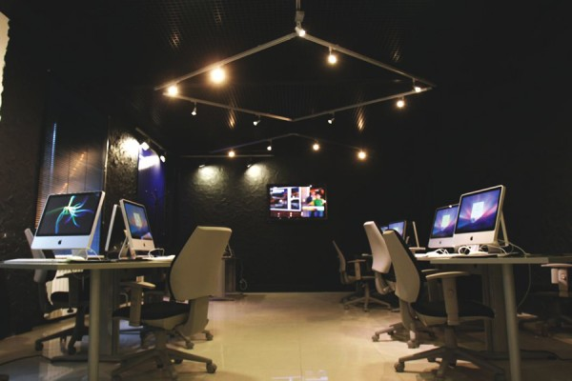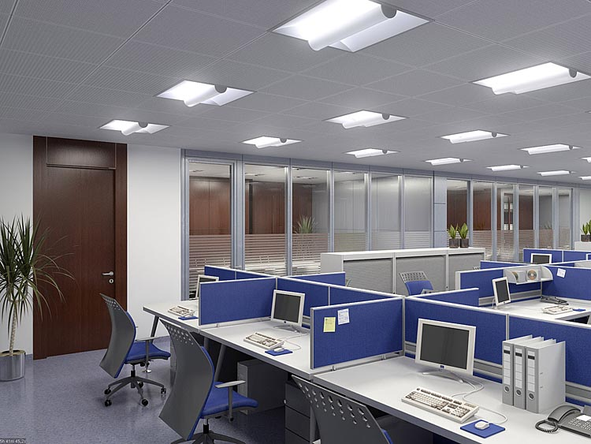
Business room: Café:
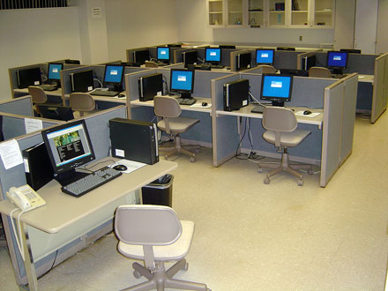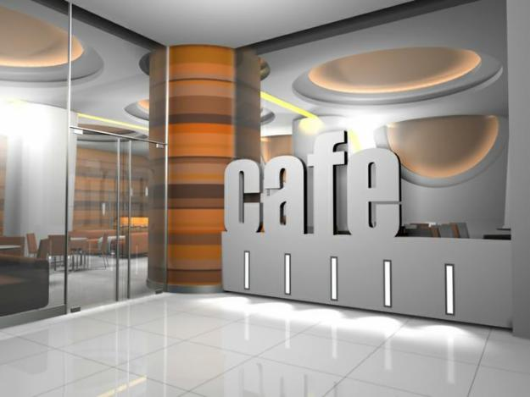
- Atmosphere.
In our cyber café each customer will get personal headphones. It will enable each customer listen to what he need without disturbing others. We hope that design of our café will maintain a pleasant atmosphere. And for VIP clients we are going to provide special private areas. We will also make special lighting in every room and it will adapt to our client base.
- Hardware and software.
We are going to use in our café only the latest computers, so we need thirty computers, because we plan to make thirty client sites, so to each computer we need web camera and headphones, and sometimes printer and scanner. Also we need some netbooks and notebooks for VIP area. To organize connection we also need modems and server. Of course we are going to use only license software, so we need such software as antivirus, programs for social networking, the latest computer games and other programs for networking.
- Internet connection.
In “Cyber field” we are going to use cable connection. Through the use of a cable modem you can have a broadband Internet connection that is designed to operate over cable TV lines. Cable Internet works by using TV channel space for data transmission, with certain channels used for downstream transmission, and other channels for upstream transmission. Because the coaxial cable used by cable TV provides much greater bandwidth than telephone lines, a cable modem can be used to achieve extremely fast access. Cable speeds range from 512 Kbps to 20 Mbps.
- How much we will charge.
We hope that our café will pay off for a year and we will be happy to get every year the same profit.
- Name and slogan.
We will name our café ICEFC what means Internet Café Easy Fast Comfortable
Our slogan: “More speed less time”.
- Advertising
We do not know much about it, so we will pay professionals to do it for us. But I think that for 400€ they will do their work perfectly and there will be no problems in clients.

This project was created by Alimov Damir and Vasilenko Anatoly.

P.S. Do not be very strict.

